**Task 11**

**Exception and error handling**

**1.** In Java, there are four access modifiers that control the visibility and accessibility of classes, methods, and variables. These modifiers are:

1. **Public**:
   * **Classes**: A class declared as public is accessible from any other class in any package.
   * **Methods**: Public methods are accessible from any other class in any package.
   * **Variables**: Public variables are accessible from any other class in any package.
2. **Protected**:
   * **Classes**: The protected modifier cannot be applied to classes.
   * **Methods**: Protected methods are accessible within the same package and by subclasses in different packages.
   * **Variables**: Protected variables are accessible within the same package and by subclasses in different packages.
3. **Default (Package-Private)**:
   * **Classes**: A class with no access modifier (default) is accessible only within its own package.
   * **Methods**: Default methods are accessible only within their own package.
   * **Variables**: Default variables are accessible only within their own package.
4. **Private**:
   * **Classes**: The private modifier cannot be applied to top-level classes. However, it can be used for inner classes.
   * **Methods**: Private methods are accessible only within the class they are declared in.
   * **Variables**: Private variables are accessible only within the class they are declared in.

**2**. Difference between Exception and error

• **Exceptions**:

* Represent conditions that an application might want to catch and handle.
* Divided into checked (must be handled or declared) and unchecked exceptions.
* Examples: IOException, NullPointerException.

• **Errors**:

* Represent serious problems that an application generally should not try to catch.
* All errors are unchecked.
* Examples: OutOfMemoryError, StackOverflowError.

3. **Difference between checked and unchecked exceptions**

**Checked Exceptions**:

* + Checked at compile-time.
  + Must be either caught or declared.
  + Used for recoverable conditions.
  + Examples: IOException, SQLException.
* **Unchecked Exceptions**:
  + Checked at runtime.
  + No requirement to catch or declare.
  + Used for programming errors.
  + Examples: NullPointerException, ArrayIndexOutOfBoundsException.

1. 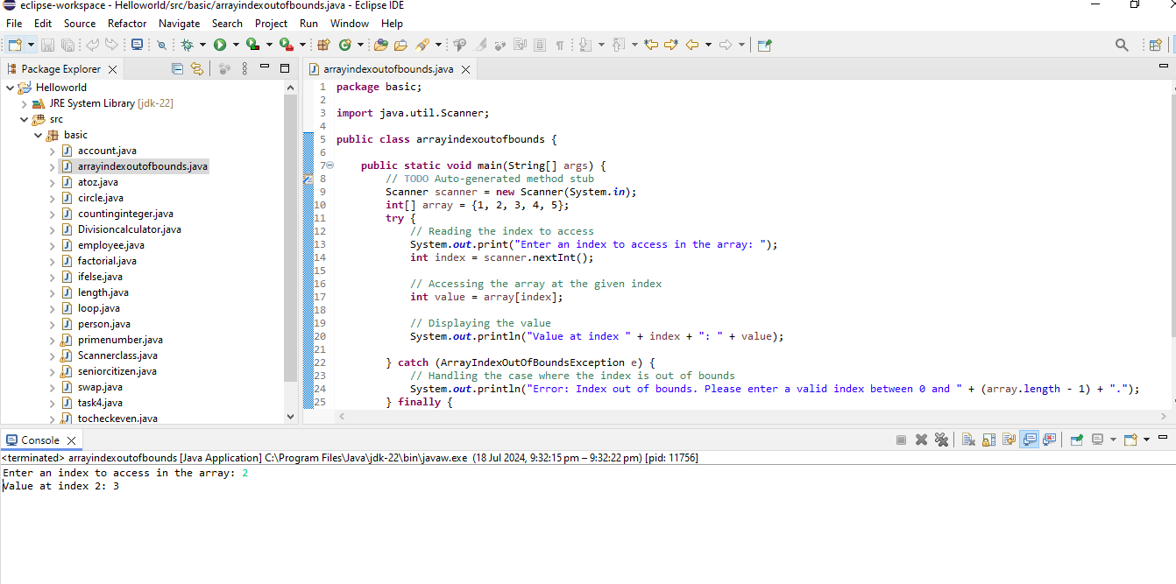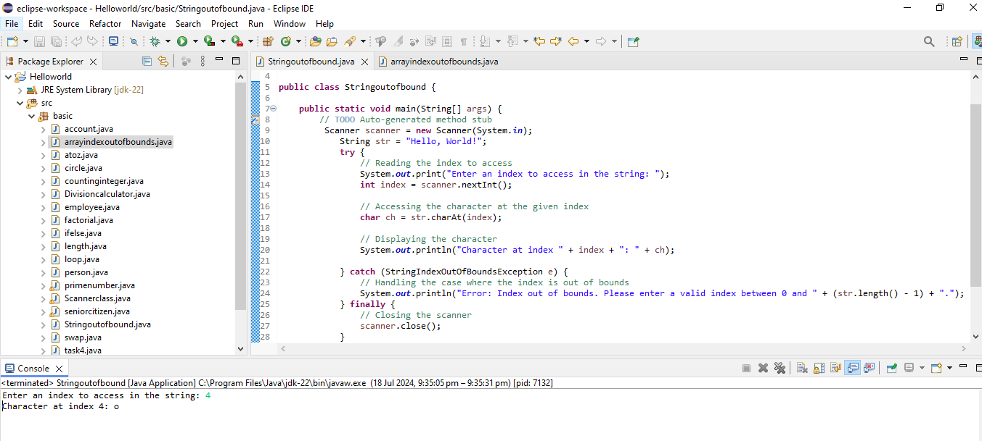

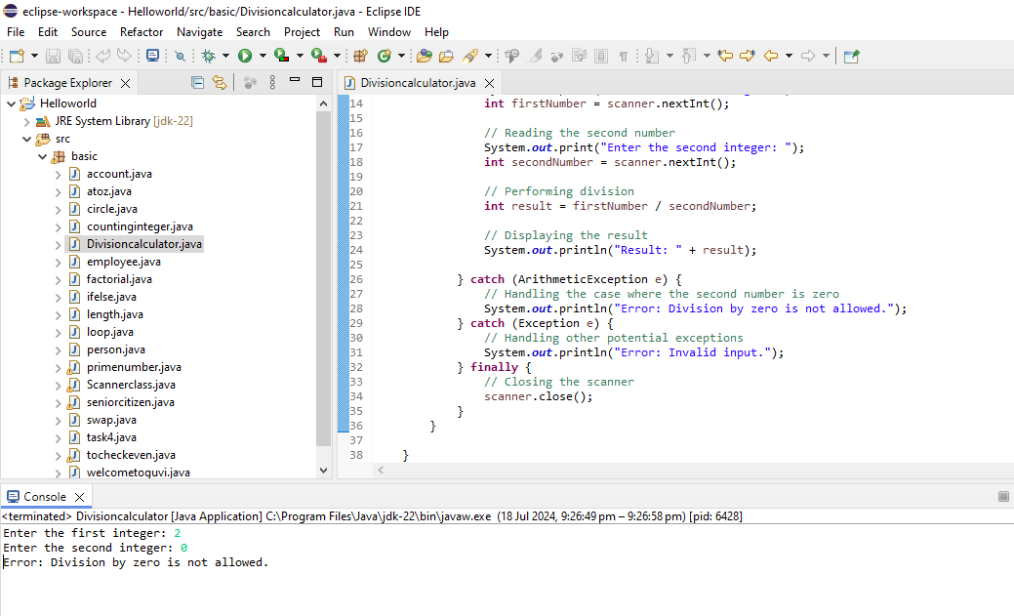

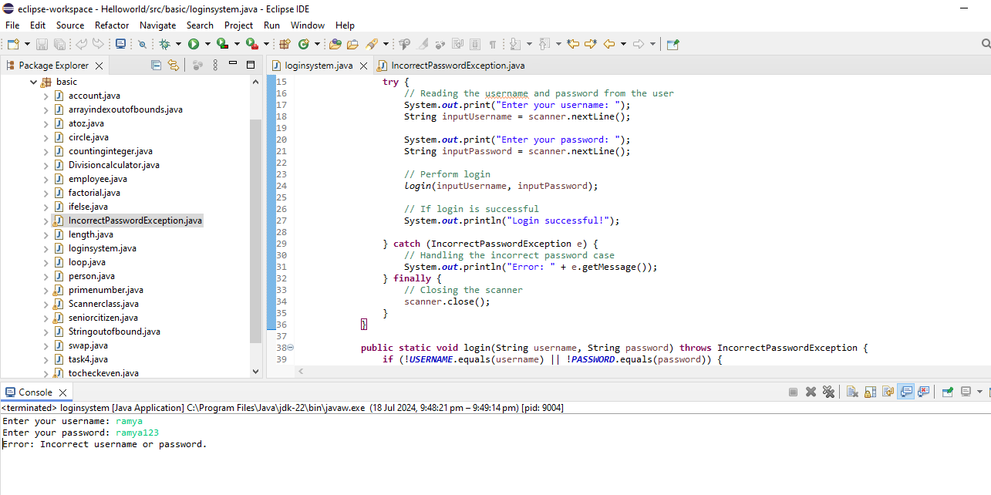

7.

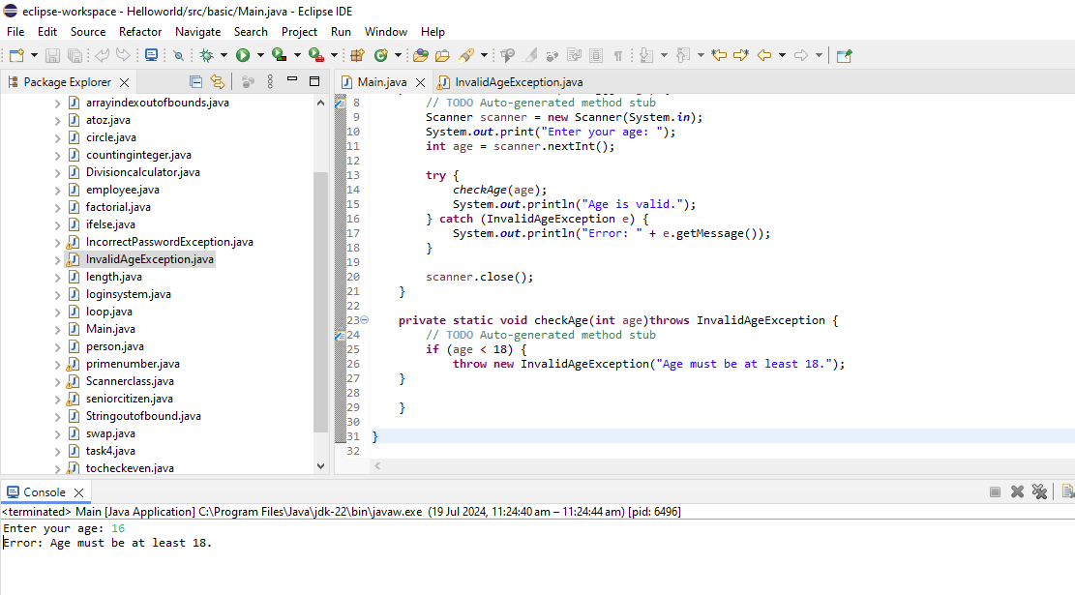

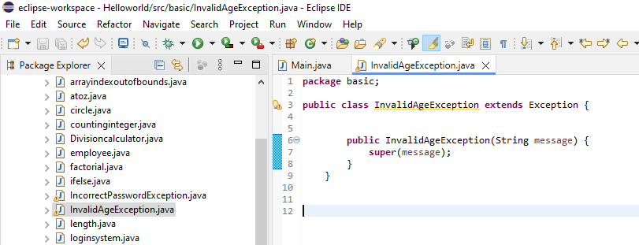

**8.** 